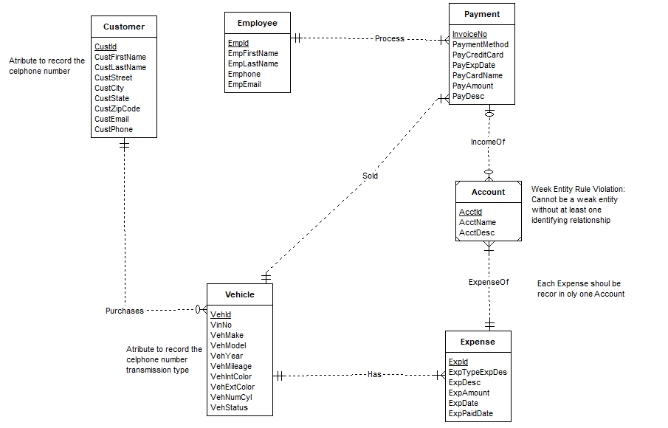

Design Error and correction

Attribute not specified: The Customer Entity Type should include the cellphone number attribute, we add one more attribute to customer;

Diagram Error and correction

Week entity Rule Violation: We add One Identifying relationship between Expense and Account.

Cardinality Error Between Account and Expenses: Each Expense should be record in only one Account we change the cardinality between Account and Expense;

